**Challenge a**

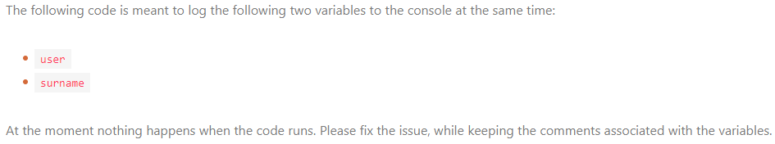

/* This is the firstname of the user /*

const user = 'John'

/* This is the lastname of the user /* const surname = 'Smith'

console.log(user; surname;)

**Challenge b**



/** (c) ACME Inc. 2010 */

/*

* This is the date that a user created their account

*/

const date = '10/07/2014'

console(date)

**Challenge c**

//

It is important to show the following message in order to:

- to assure users

- to scare hackers

- to impress investors

//

console.warn(Security scan starting)

/* It is important to let user know when they can close the page /*

cnosole.info('Please wait for scan to complete before closing the browser.)